## Recovery dynamics of experimentally warmed/degraded PNW grasslands aided by burning to remove thatch feedbacks maintaining alternative stable states. (Annual grass resilience and the nature of state change dynamics)

*Alejandro Brambila – 01.22.2020*

Pacific Northwest (PNW) Mediterranean perennial grasslands provide a counterpoint to the rapid historic transition of California’s perennial grasslands to annual dominance. This transition, “one of the best known examples of large-scale community change occurring in North America over the past two centuries”, was precipitated by the novel agricultural disturbance imposed by colonial settlers (Corbin and D’Antonio 2004; Vaughn et al. 2011). Additionally, California’s hot, dry summers created an ideal home for Mediterranean annual grasses pre-adapted to such conditions (Clary 2008; HilleRisLambers et al. 2010; Jackson 1985). While non- native perennial pasture grasses have invaded grasslands north of the Klamath range, most PNW grasslands have so far resisted the more fundamental state-change to annual dominance. **My overarching goal is to understand the resilience of the annual grass dominated state in the PNW.** To do this,I will examine the **dynamics of perennial recovery via state change from annual and perennial dominance.**

State transition models were developed to study grassland dynamics in the ongoing effort to restore perennial grasslands in California. These models define ecosystem states and the forces necessary to move between them (Westoby 1989; George, 1992). State-change can be driven deterministically by crossing an environmental threshold, or states can exhibit “hysteresis” dynamics where multiple ecosystem states become possible for the same environmental condition (Fig 2). Each state has a “basin of attraction”, a range of conditions where internal feedbacks lead to community convergence on that state. This results in a system whose trajectory depends not only on environmental conditions, also on starting ecosystem state (Beisner et al. 2003; Suding and Hobbs 2009)

Under climate change the PNW mean annual temperature is expected to increase by 2.7 to 6°C by 2100 due to anthropogenically induced climate change, mirroring an expected global increase of 1.8-4°C (Dalton, 2017; Intergovernmental Panel on Climate Change 2014). PNW grasslands can also expect to experience increased seasonal and interannual cilmat variability in addition to As the PNW’s climate becomes more favorable to annual grasses, there is potential for losses of perennial grasses from prairie landscapes. For example, researchers at the University of Oregon demonstrated widespread perennial die-off and annual grass invasion in a warming experiment across a latitudinal gradient in the PNW (Pfeifer-Meister et al. 2016; unpublished data). A “Californication” of PNW grasslands would bring a number of risks, including increased fire frequency, soil carbon loss, an increase in noxious weeds, increased erosion, a shortened forage season , and reduced biodiversity (Carlsen, Menke, and Pavlik 2000; Maret and Wilson 2005; Stein et al. 2014; Vitousek 1992).

Under climate change, PNW Mediterranean grasslands will experience increased seasonal and interannual climate variability addition to directional warming. Summers are getting hotter and drier, and winters are getting wetter. The El Niño Southern and Pacific Decadal Oscillations, which already drive significant interannual climate variability, are predicted to increase in frequency and intensity, leading to more extreme heat, precipitation and drought events (Dalton, 2017; Rundel et al. 2016).

Here, I ask whether this system exhibits a deterministic response to warming or if biotic feedbacks reinforce annual dominance once established. This will have implications for permanence of state-change and potential for recovery in a more variable future. I will compare passive and active perennial recovery (seeding, burning) from variable levels of annual dominance established through a combination of latitude and heat legacy.

Experimental climate manipulations at three sites across a latitudinal environmental gradient in the Pacific Northwest (Table 1), called Heating of Prairie Systems (HOPS), developed a wealth of data about how grasslands respond to 2.5-3°C warming throughout the region. This recently completed work demonstrated a shift towards annual dominance in the central and southern sites, which was exacerbated by warming (Pfeifer-Meister et al. 2016, Fig 1). Grounding this chapter of my research in the established HOPS framework, I will test the ability of perennials to recover in now annual-dominated plots, as cooling after a heat wave may be common.

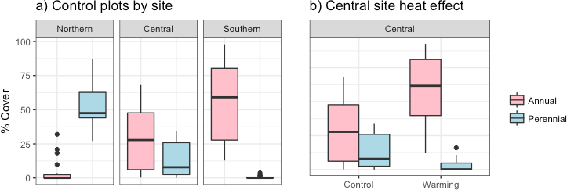

*Figure 1: a) Mean percent cover of annual grasses and perennial grasses in control plots at southern, central and northern HOPS sites (See Table 1) in 2018. b) Effect of warming legacy on plots at the central HOPS site.*

**Hypotheses (Figure 3):** My overarching hypothesis is that state-change in PNW grasslands will exhibit hysteresis dynamics at intermediate latitudes, resulting in persistent annual grass dominance once established. I will test this hypothesis by comparing trajectories of passive and aided perennial grass recovery in communities with a range of annual dominance across latitudes. Specifically, I hypothesize that **hysteresis occurs at the central but not at the southern or northern site (H1)**, and that **annual grass thatch is the primary biotic feedback driving this dynamic (H2)**. To test H1, I will compare passive recovery trajectories across sites as measured by changes in the ratio of annual to perennial cover. To account for perennial seed limitation, I applied a perennial seeding treatment. To test H2, I will compare passive recovery trajectories to those in which annual thatch has been removed through prescribed burning.

Hypothesis 1 will be supported by stable or increasing perennial dominance in all plots at the northern site, stable or increasing annual dominance in all plots at the southern site, and most importantly for this hypothesis, increasing annual dominance in plots with more initial annual cover and increasing perennial dominance in plots with more initial perennial cover at the central site. Hypothesis 2 will be supported if annual dominance increases in unburned plots, but perennial dominance increases in burned plots. It will also be supported if seeding into plots with thatch does not increase perennial dominance. These results would suggest that much of the PNW Mediterranean grasslands already exist under the environmental conditions that can support annual dominance, and that a heat wave could cause a difficult to reverse state-change.

Methods

**Study system:** The Mediterranean climate, defined by mild, wet winters and hot, dry summers occurs in a narrow band along the Pacific coast (Rundel et al. 2016). This region is experiencing hotter, drier, and longer summers (Dalton et al. 2017). Lowlands within this region are widely settled and have been intensely managed since the first humans arrived over 15,000 years ago. Before colonization, first nations burned the landscape to manipulate plant and animal populations, maintaining an open, grassland biome (Shelvey and Boyd 2006). These perennial grasslands developed a unique, fire-dependent flora and fauna which provide multiple ecosystem services including pollination, cattle pasture, carbon sequestration and indigenous cultural value (Hamman et al. 2011; Menke 1992). Today, about 39 million Washingtonians, Oregonians and Californians call these grasslands home. Development, agriculture and industry supporting this massive population have reduced and fragmented grasslands to a fraction of their former extent, while loss of prescribed fire, agricultural disturbance and species invasions have led to novel species assemblages. Recognizing the value of remaining PNW Mediterranean grasslands, efforts are well underway to conserve grassland remnants and restore connectivity, biodiversity and services, but climate change presents a new threat. Management is often reactionary, and in systems with biotic feedbacks intervention is often too late. Our ability to manage remaining Mediterranean grasslands under novel climate conditions will determine the future of this system in the PNW.

I will use communities established by the HOPS experiment which ended in 2018 and consisted of sixty plots divided evenly between three sites in the PNW (Table 1). The central and southern plots were cleared using 2% glyphosate in 2009, and seeded with a mix of 29 regionally cosmopolitan native species including perennial grasses (Pfeifer-Meister et al. 2016). The northern plot was added in fall 2014 and underwent the same treatment, at which time the existing plots were mown, raked and reseeded to reestablish similar starting conditions. Native seedlings were allowed to establish for the 2015 growing season, after which ten randomly selected plots at each site were warmed to an average of 2.5-3°C above ambient using infrared heaters from 2016- 2018 (Reed et. al. 2019). Community composition was monitored for each site at peak biomass in June 2018, at which point annuals had successfully invaded the central and southern sites, while perennials recovered at the northern site (Figure 1).

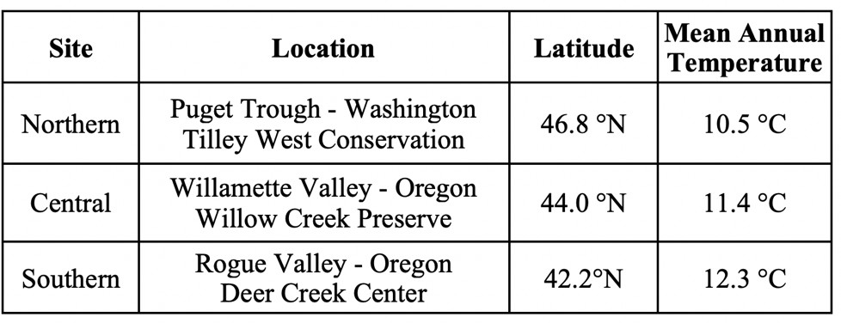

*Table 1: HOPS plot locations across the Pacific Northwest*

To test for hysteresis, I installed a fully factorial design adding perennial seeds and burning (a commonly used method) to remove thatch within each of the existing plots (Alstad, Damschen, and Ladwig 2018; Pyke, Brooks, and D’Antonio 2010). I nested paired burned/unburned sub-plots in each plot, and further subdivided these into 30 cm x 30 cm seeding microplots. I established subplots along a north-south axis within plots and randomly assigned one plot to have thatch removed by prescribed burn. Each subplot has a 10 cm buffer to minimize edge effects. I burned to remove thatch between September and November 2018 using a 1m2 aluminum burn-box in collaboration with local fire experts (Supplement 1 & 2, p.11). Burn boxes are an alternative to full- pasture prescribed fire that have been successfully used across western grasslands to reproduce typical prescribed fire effects at a small scale (Sharrow and Wright 2018; White and Currie 1983). I burned in low wind conditions from late morning to early evening. Fuels were ignited with wax paper or propane flame in a backing fire that burned top down. I relit fires with a torch if they went out before all fine fuels were consumed. Each site was burned on the earliest fall day permitted by local fire restrictions and I recorded maximum observed temperatures during burns using an infrared thermometer. Within ten days of each burn, I randomly selected two 30 cm x 30 cm microplots (out of eight possible) for seeding treatments and seeded one with a common native perennial grass, *Festuca roemeri*, and left one as a control. Each seeded microplot received 0.8 grams of seed. Each combination of site, warming legacy, burning, and seeding was replicated ten times.

I will measure community composition at peak standing biomass in June 2019 and 2020. Specifically, I will inventory all individuals in the central 10 cm x 10 cm of each microplot to avoid edge effects. I will calculate the relative proportion of each individual species and aggregate annual and perennial grass counts to calculate an index of perennial and annual dominance: the ratio of relative annual to perennial cover. To address my hypotheses, I will run a separate three-way ANOVA for each of the 3 sites, with seeding plots nested in burn plots, nested in HOPS plots and using heat legacy, burn and seeding treatments as factors. Trajectories will be determined by testing for significant differences of annual and perennial grass dominance ratios between applied treatments and baseline conditions, and across treatments (as appropriate to each hypothesis, described in expected results). I will test for significance using Tukey’s post hoc comparison of burned and unburned plots. Significant difference will be determined at alpha <0.05. Finally, I will perform NMDS on individual species’ relative abundance and run perMANOVA to test if my dominance index (represented as a factor) is a major driver of community composition.

Hysteresis is driven by endogenous biotic feedbacks which may buffer ecosystem response to climate change, but may also prevent ecosystem recovery following temporarily extreme conditions. Under hysteresis, perennials may persist despite some warming but be unable to recover once invaded by annuals (Lulow 2006; Seabloom et al. 2003). A likely driver of hysteresis in this system is annual grass thatch, standing biomass that reduces the establishment of perennials and increases growth and seed production of annuals (Mariotte et al. 2017). This leads to a positive feedback where annual grasses can establish but perennials cannot. If annual dominance is a self-reinforcing state, temporary heating events could accelerate a difficult to reverse state-change. Both annual and perennial grasslands are resistant to invasion in California, a pattern that suggests hysteresis, but structured manipulative experiments across a wide range of external environmental conditions are necessary to establish discontinuous shift thresholds and test stability of each state across conditions (Corbin and D’Antonio 2004; Standish et al. 2014). Having established variable levels of annual dominance in conditions that previously supported perennial grasslands (Fig 1 & 2), **the HOPS infrastructure provides a unique opportunity to test for a hysteresis effect where annual grasses remain post warming.**



**+ Temperature**

*Figure 2: Ecosystem state isoclines (red and blue lines) plotted across a temperature gradient. Perennial and annual basins of attraction (corresponding background color) overlap at intermediate conditions, creating a hysteresis effect where alternate stable states are possible. Points represent relative spring 2018 starting conditions established by the HOPS experiment (Figure 1)*

*given their latitudinal position (Table 1). Reference pasture at all latitudes are perennial dominated.*

**S**

**C**

Not warmed Warmed

**N**

**Ecosystem**

**State**

Annual

Perennial

**State**

Annual

Perennial

**Ecosystem**



*trajectory. a) Divergent trajectories at central plots is evidence for hysteresis. No evidence for hysteresis at northern and southern sites. b) Burning reduces annual basin of attraction. Central plots are both on a perennial trajectory.*

Not warmed Warmed

Northern Central Southern

**+ Temperature** *Figure3: Chapter 1, Illustrated hypotheses. Perennial and annual isoclines and domains of attraction determine community*

**H2**

**b)**

**H1**

**a)**

## Conclusion:

While perennial grasses have maintained dominance in PNW grasslands despite invasion and disturbance pressure, their dominance may be reaching its limit. Hotter, drier summers and more frequent heat waves may allow annual grasses to take over. This transition would bring with it changes in nutrient cycling, fire regimes, coexistence with other grassland species, and grassland ecosystem services like forage. Because annual grasses invaded plots that had been restored then warmed, my dissertation performs the important role of considering potential unexpected side effects of management actions taken under climate change. Understanding how resilience will affect state-change dynamics, and which mechanisms influence competitive outcomes will increase the predictability of state-change and help increase the success rate of restoration. Predictability will be helpful for managers faced with the threat of climate change that have to make decisions that affect annual and perennial competitive dynamics.

## References:

Adler, Peter B., James Leiker, and Jonathan M. Levine. 2009. “Direct and Indirect Effects of Climate Change on a Prairie Plant Community.” *PLoS ONE*.

Alstad, Amy O., Ellen I. Damschen, and Laura M. Ladwig. 2018. “Fire as a Site Preparation Tool in Grassland Restoration: Seed Size Effects on Recruitment Success.” *Ecological Restoration*.

Aronson, Emma L., and Steven G. McNulty. 2009. “Appropriate Experimental Ecosystem Warming Methods by Ecosystem, Objective, and Practicality.” *Agricultural and Forest Meteorology*.

Beisner, B. E., D. T. Haydon, and K. Cuddington. 2003. “Alternative Stable States in Ecology.” *Frontiers in Ecology and the Environment*.

Buhrmann, Rowan D., Syd Ramdhani, Norman W. Pammenter, and Sershen Naidoo. 2016. “Grasslands Feeling the Heat: The Effects of Elevated Temperatures on a Subtropical Grassland.” *Bothalia*.

Carlsen, Tina M., John W. Menke, and Bruce M. Pavlik. 2000. “Reducing Competitive Suppression of a Rare Annual Forb by Restoring Native California Perennial Grasslands.” *Restoration Ecology*.

Clary, Jeffrey. 2008. “Rainfall Seasonality Determines Annual/Perennial Grass Balance in Vegetation of Mediterranean Iberian.” *Plant Ecology*.

Corbin, Jeffrey D., and Carla M. D’Antonio. 2004. “Competition between Native Perennial and Exotic Annual Grasses: Implications for an Historical Invasion.” *Ecology*.

Daltom, M.M., K.D. Dello, L. Hawkins, P.W. Mote, and D.E. Rupp. 2017. *The Third Oregon Climate Assessment Report January 2017*. Corvallis, Oregon.

Davies, Kirk W., Aleta M. Nafus, and Roger L. Sheley. 2010. “Non-Native Competitive Perennial Grass Impedes the Spread of an Invasive Annual Grass.” *Biological Invasions*.

Farrer, Emily C., Isabel W. Ashton, Jonas Knape, and Katharine N. Suding. 2014. “Separating Direct and Indirect Effects of Global Change: A Population Dynamic Modeling Approach Using Readily Available Field Data.” *Global Change Biology*.

Franco, Miguel, and Jonathan Silvertown. 2004. “A Comparative Demography of Plants Based upon Elasticities of Vital Rates.” *Ecology*.

George, Melvin R., Joel R. Brown, and W. James Clawson. 2007. “Application of Nonequilibrium Ecology to Management of Mediterranean Grasslands.” *Journal of Range Management*.

Gilman, Sarah E. et al. 2010. “A Framework for Community Interactions under Climate Change.” *Trends in Ecology and Evolution*.

Godfree, Robert et al. 2011. “An Improved Hexagon Open-Top Chamber System for Stable Diurnal and Nocturnal Warming and Atmospheric Carbon Dioxide Enrichment.” *Global Change Biology*.

Hamilton, Jason G., Claus Holzapfel, and Bruce E. Mahall. 1999. “Coexistence and Interference between a Native Perennial Grass and Non-Native Annual Grasses in California.” *Oecologia*.

Hamman, Sarah T., Peter W. Dunwiddie, Jason L. Nuckols, and Mason McKinley. 2011. “Fire as a Restoration Tool in Pacific Northwest Prairies and Oak Woodlands: Challenges, Successes, and Future Directions.” *Northwest Science*.

HENRY, G.H.R., and U. MOLAU. 2003. “Tundra Plants and Climate Change: The International Tundra Experiment (ITEX).” *Global Change Biology*.

HilleRisLambers, Janneke, Stephanie G. Yelenik, Benjamin P. Colman, and Jonathan M. Levine. 2010. “California Annual Grass Invaders: The Drivers or Passengers of Change?” *Journal of Ecology*.

Intergovernmental Panel on Climate Change. 2014. Climate Change 2014: Synthesis Report. Contribution of Working Groups I, II and III to the Fifth Assessment Report of the Intergovernmental Panel on Climate Change *Climate Change 2014 Synthesis Report - IPCC*.

Ives, A. R. 1995. “Predicting the Response of Populations to Environmental Change.” *Ecology*.

Jackson, Louise E. 1985. “Ecological Origins of California’s Mediterranean Grasses.” *Journal of Biogeography*. Lambers, Janneke Hille Ris. 2015. “Extinction Risks from Climate Change: How Will Climate Change Affect Global

Biodiversity?” *Science*.

Larios, Loralee, Lauren M. Hallett, and Katharine N. Suding. 2017. “Where and How to Restore in a Changing World: A Demographic-Based Assessment of Resilience.” *Journal of Applied Ecology* 54(4): 1040–50.

Lulow, Megan E. 2006. “Invasion by Non-Native Annual Grasses: The Importance of Species Biomass, Composition, and Time among California Native Grasses of the Central Valley.” *Restoration Ecology*.

Maret, Mary P., and Mark V. Wilson. 2005. “Fire and Litter Effects on Seedling Establishment in Western Oregon Upland Prairies.” *Restoration Ecology*.

Marion, G M et al. 1997. “Open-Top Designs for Manipulatin Field Temperature in High-Latitude Ecosystems.” *Global Change Biology*.

Mariotte, Pierre, Erica N. Spotswood, Emily C. Farrer, and Katharine N. Suding. 2017. “Positive Litter Feedbacks of an Introduced Species Reduce Native Diversity and Promote Invasion in Californian Grasslands.” *Applied Vegetation Science*.

Menke, John W. 1992. “Grazing and Fire Management for Native Perennial Grass Restoration in California Grasslands.”

*Fremontia*.

Mordecai, Erin A. et al. 2015. “Controls over Native Perennial Grass Exclusion and Persistence in California Grasslands Invaded by Annuals.” *Ecology*.

Pfeifer-Meister, Laurel et al. 2016. “Climate Change Alters Plant Biogeography in Mediterranean Prairies along the West Coast, USA.” *Global Change Biology*.

Pfeifer-Meister, Laurel, Esther M. Cole, Bitty A. Roy, and Scott D. Bridgham. 2008. “Abiotic Constraints on the Competitive Ability of Exotic and Native Grasses in a Pacific Northwest Prairie.” *Oecologia*.

Pyke, David A., Matthew L. Brooks, and Carla D’Antonio. 2010. “Fire as a Restoration Tool: A Decision Framework for Predicting the Control or Enhancement of Plants Using Fire.” *Restoration Ecology*.

Reed, Paul. Pfeifer-Meister, Laurel. Roy, Bitty. Johnson, Bart. Bailes, Graham. Nelson, Aaron. Boulay, Margaret. Hamman, Sara. Bridgham, Scott. 2019. “Prairie Plant Phenology Driven More by Temperature than Moisture in Climate Manipulations across a Latitudinal Gradient in the Pacific Northwest, USA.” *Ecology and Evolution* In press.

Rundel, Philip W et al. 2016. “Mediterranean Biomes: Evolution of Their Vegetation, Floras and Climate.” *Annual Review of Ecology, Evolution, and Systematics*.

Seabloom, E. W., W. S. Harpole, O. J. Reichman, and D. Tilman. 2003. “Invasion, Competitive Dominance, and Resource Use by Exotic and Native California Grassland Species.” *Proceedings of the National Academy of Sciences*.

Sharrow, Steven H, and Henry A Wright. 2018. “Production in the Rolling Plains Effects of Fire, Ash, and Litter on Soil Nitrate, Temperature, Moisture and Tobosagrass Production in the Rolling Plains.” *Society for Range Management* 30(4): 266–70.

Shelvey, Bruce, and Robert Boyd. 2006. “Indians, Fire, and the Land in the Pacific Northwest.” *The Western Historical Quarterly*.

Standish, Rachel J. et al. 2014. “Resilience in Ecology: Abstraction, Distraction, or Where the Action Is?” *Biological Conservation* 177: 43–51.

Stein, Claudia, Lauren M. Hallett, W. Stanley Harpole, and Katharine N. Suding. 2014. “Evaluating Ecosystem Services Provided by Non-Native Species: An Experimental Test in California Grasslands.” *PLoS ONE*.

Stromberg, Mark R., and James R. Griffin. 1996. “Long-Term Patterns in Coastal California Grasslands in Relation to Cultivation, Gophers, and Grazing.” *Ecological Applications*.

Suding, Katharine N., and Richard J. Hobbs. 2009. “Threshold Models in Restoration and Conservation: A Developing Framework.” *Trends in Ecology and Evolution*.

Thomas, Chris D. et al. 2004. “Extinction Risk from Climate Change.” *Nature*.

Tylianakis, Jason M., Raphael K. Didham, Jordi Bascompte, and David A. Wardle. 2008. “Global Change and Species Interactions in Terrestrial Ecosystems.” *Ecology Letters*.

Vaughn, Kurt J. et al. 2011. “California Perennial Grasses Are Physiologically Distinct from Both Mediterranean Annual and Perennial Grasses.” *Plant and Soil*.

Vitousek, P. 1992. “Global Environmental Change: An Introduction.” *Annu. Rev. Ecol. Syst.*

Westoby, Mark, Brian Walker, and Imanuel Noy-Meir. 2007. “Opportunistic Management for Rangelands Not at Equilibrium.” *Journal of Range Management*.

White, Richard S, and Pat O Currie. 1983. “Prescribed Burning in the Northern Great Plains: Yield and Cover Responses of 3 Forage Species in the Mixed Grass Prairie.” *Society for Range Management* 36(2): 179–83.

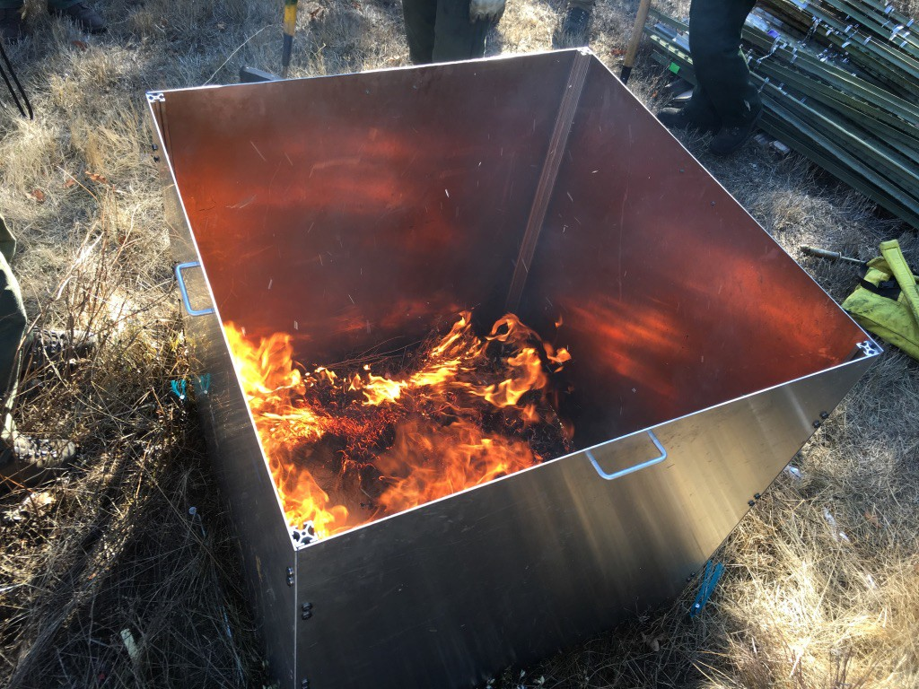

***Supplemental Figure 1****: A typical burn in aluminum burn box at the Central site.*

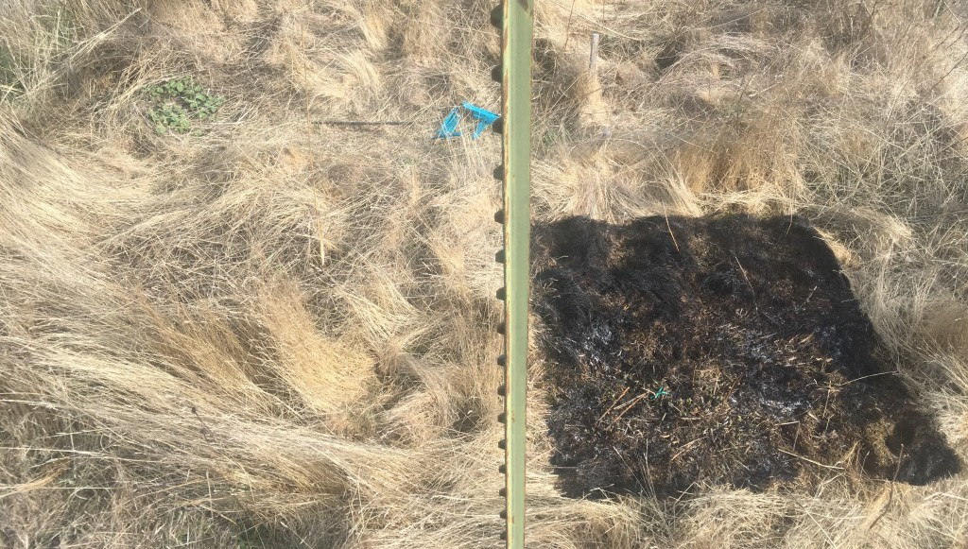

b)

a)

***Supplemental Figure 2****: Typical effect of burning in experimental plots. a) unburned subplot. b) burned subplot*

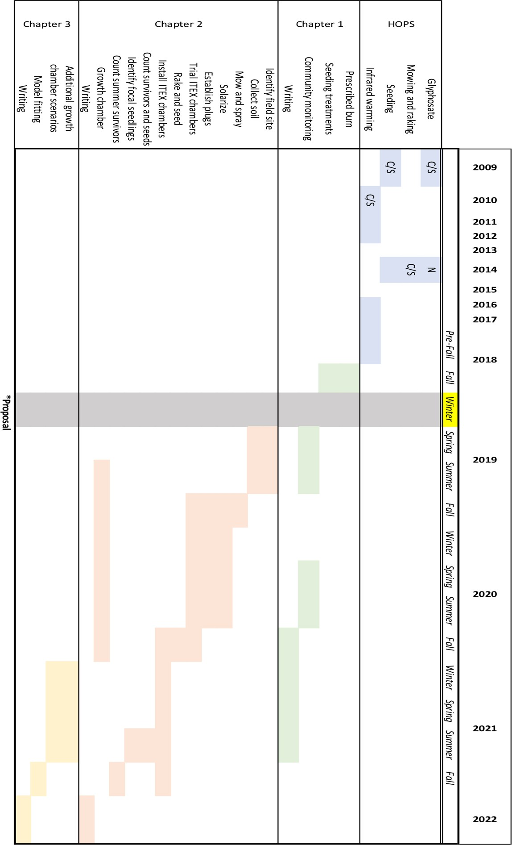

***Supplemental Figure 3:*** *Proposed dissertation timeline. Colors represent chapters, with blue representing past HOPS experiment. C/N/S notation represents central/northern/southern HOPS plots. The gray row represents the current period.*